Anguler with WebCam
Routing now I have 2 compnets
Home
Webrtc
I want to used in navbar so
1st
frontend/src/app/component/home/ -> create this folder structure
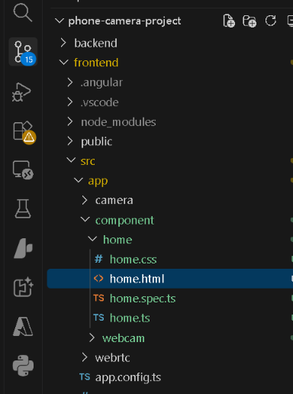
run this from your frontend folder:
ng generate component component/home
ng g c component/home short

1. Put navbar in home.html
Open:
src/app/component/home/home.html
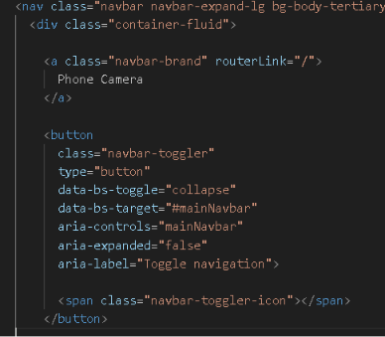

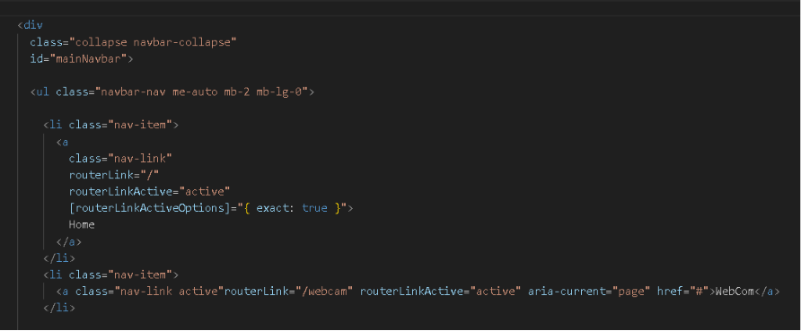

2. Add RouterLink to home.ts
Open:
src/app/component/home/home.ts
Because this is a standalone Angular component, import RouterLink and RouterLinkActive.
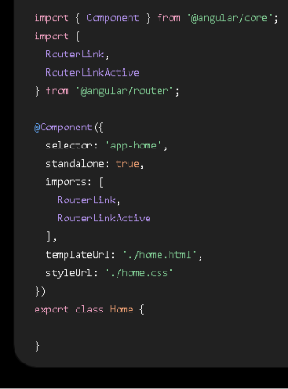

3. Now routing
Open:
src/app/app.routes.ts
Put:
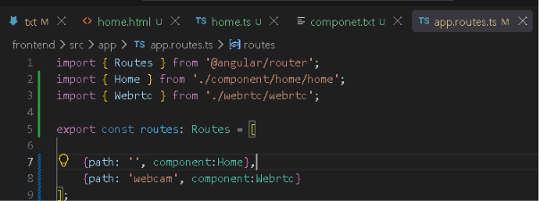

4. Make sure app.ts has RouterOutlet
Open:
src/app/app.ts
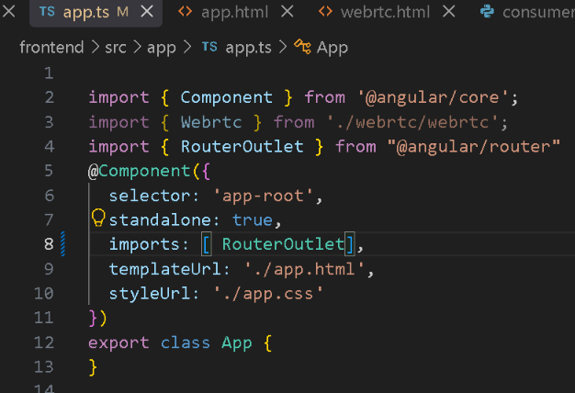
1. Install Bootstrap
From your frontend folder:
npm install bootstrap @popperjs/core

2. Install Tailwind CSS
For a current Angular project, use:
npm install tailwindcss @tailwindcss/postcss postcss
create -> .postcssrc.json
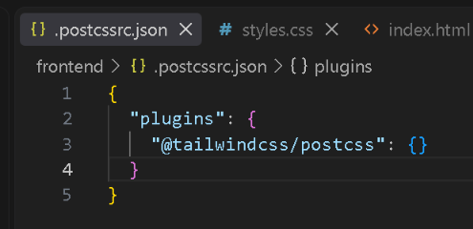

To start the server go in project directory
Backend
Step 1 — Start Django/Daphne
Open Terminal 1:
cd "D:\Dhananjay AWS\Django Projects\phone-camera-project\backend"
daphne -b 0.0.0.0 -p 8000 backend.asgi:application
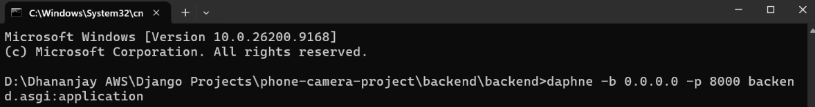

Step 2 — Start Angular with HTTPS
Open Terminal 2:
Start frontend
1.In vs code
cd "D:\Dhananjay AWS\Django Projects\phone-camera-project\frontend" ng serve
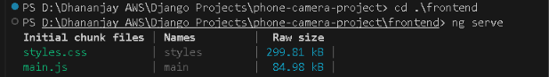
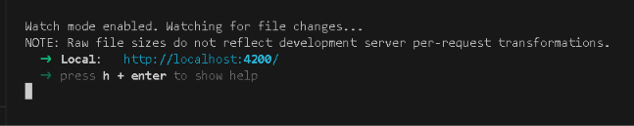
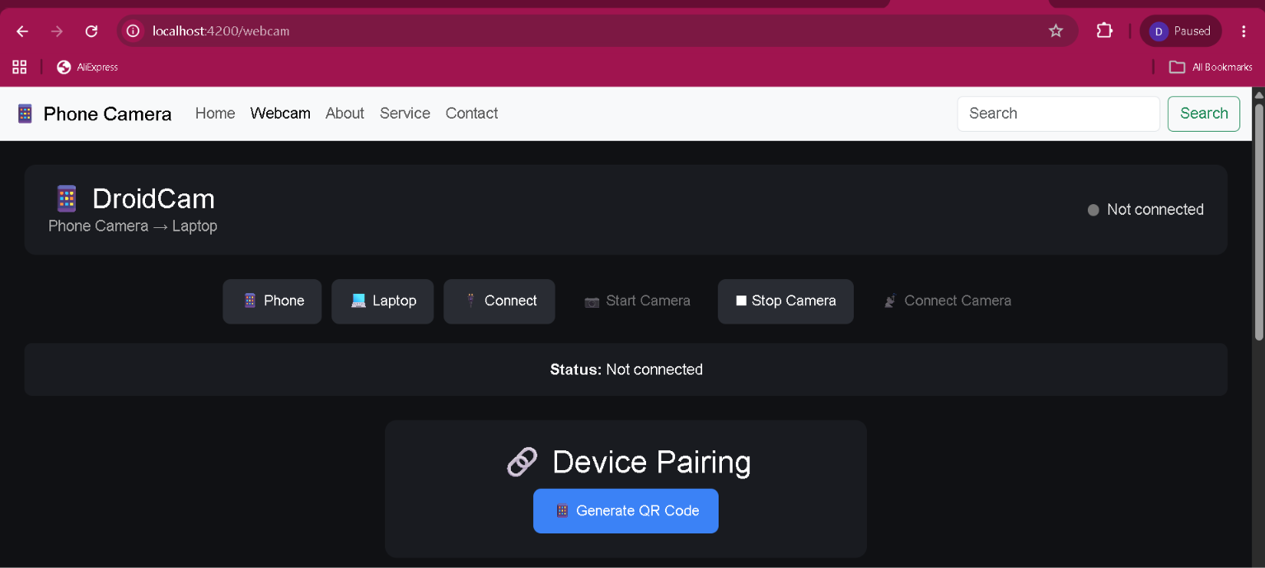

2.open terminal
ng serve --host 0.0.0.0 --ssl --ssl-cert ssl/cert.pem --ssl-key ssl/key.pem

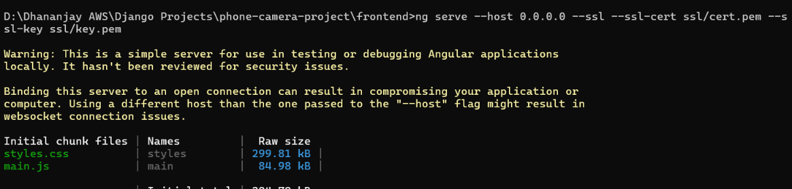
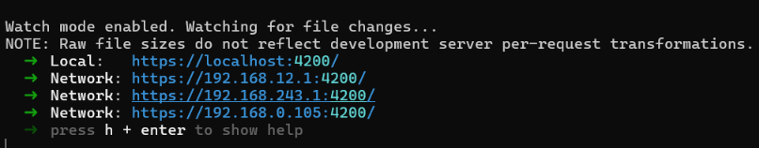

For same port in vs and frontend use this
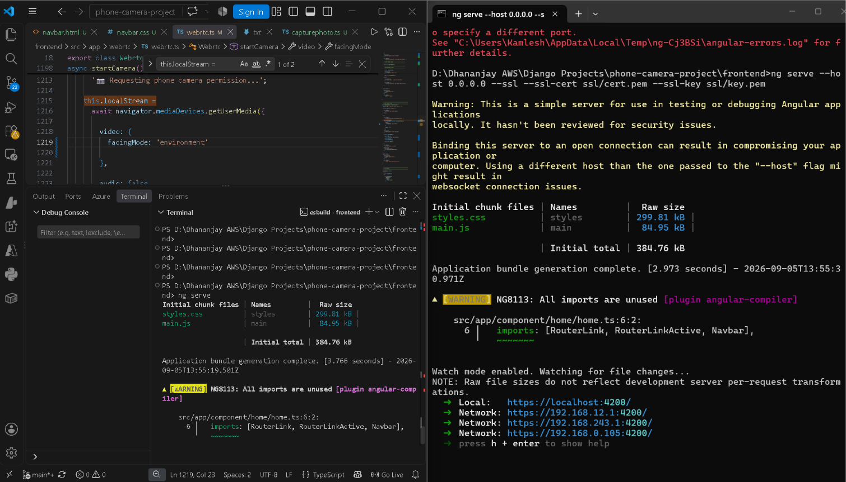

Step 3 — Open the website
Laptop
Open:
https://localhost:4200/
Phone
Open:
https://192.168.0.105:4200/
The important thing is that the phone uses:

Terminal 1 — Angular frontend
cd "D:\Dhananjay AWS\Django Projects\phone-camera-project\frontend"
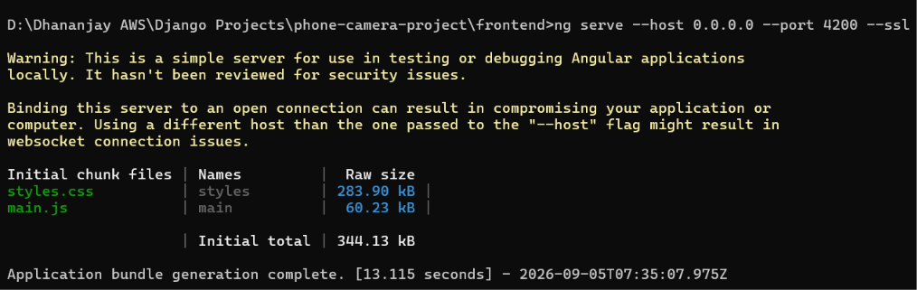

Laptop ➜ Local: https://localhost:4200/
Phone- ➜ Network: https://192.168.0.105:4200/
